**20 May**

**Python Basic - 1**

**Q.1. What are keywords in python? Using the keyword library, print all the python keywords.**

Answer: 1. Keywords are pre-defined and reserved words in python.

2. Keywords cannot use as variable name, function name or any other identifier.

3.keywords are used to define syntax and structure of python language.

4.All the keywords except True, False and None are in lowercase and they must be written as they are.

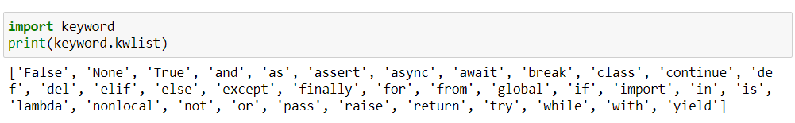

**Q.2. What are the rules to create variables in python?**

Answer: 1. Constant and variable names should have a combination of letters in lowercase(a to z) or uppercase(A to Z) or digits(0 to 9) or an underscore( _ )

2. Create a name that makes sense. [for example, vowel makes more sense than v].

3.If you want to create a variable name having two words, use underscore ( _ ) to separate them.

4.It is case-sensitive [For example: num and Num are different variables]

5.Avoid using keywords like if , True , class etc as a variable names.

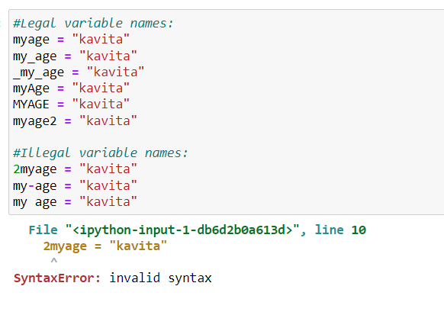

6. Here it is error because of the digit

**Q.3. What are the standards and conventions followed for the nomenclature of variables in python to improve code readability and maintainability?**

1. Constant and variable names should have a combination of letters in lowercase(a to z) or uppercase(A to Z) or digits(0 to 9) or an underscore( _ )

2. Create a name that makes sense. [for example, vowel makes more sense than v].

3.If you want to create a variable name having two words, use underscore ( _ ) to separate them.

4.It is case-sensitive [For example: num and Num are different variables]

5.Avoid using keywords like if , True , class etc as a variable names.

**Q.4. What will happen if a keyword is used as a variable name**

**Answer:** As we know that keywords are predefined or reserved words in python, we cannot use keyword as a variable name or function name or an identifier.

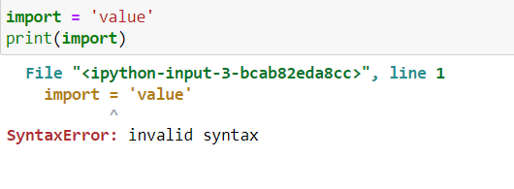

**Q.5. For what purpose def keyword is used?**

**Answer: To define a function “ def ” keyword is used**

**Syntax:** 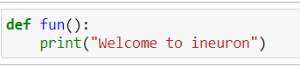

**Q.6. What is the operation of this special character ‘\’?**

**Answer: In python strings, the backslash “ \ ” is a special character, also called the “ escape ” character. It is used in representing certain whitespace characters.**

**"\t" is a tab, "\n" is a newline**

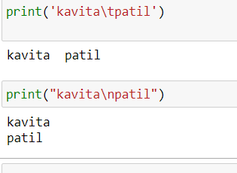

**Q.7. Give an example of the following conditions:**

**(i) Homogeneous list**

**(ii) Heterogeneous set**

**(iii) Homogeneous tuple**

**Answer: (i) Homogeneous list:-** Data elements will be of same data type

String, int and Boolean data types:

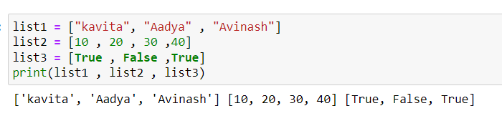

**(ii) Heterogeneous set: -** Data elements will be of different data type

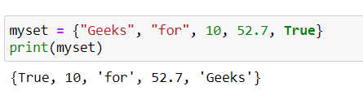

**(iii) Homogeneous tuple: -** Data elements will be of same data type

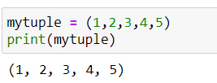

**Q.8. Explain the mutable and immutable data types with proper explanation & examples.**

**Answer: Mutable: -** A mutable object can be changed after it's created

**Immutable:** An immutable object can't be changed.

**Mutable** [change after creation] data type in Python

- List

- Sets

- Dictionary

**Immutable** [cannot change or we can delete] data type in Python

- Numbers

- Strings

- Tuples

|  |  |  |  |  |
| --- | --- | --- | --- | --- |
| **String** | **List** | **Tuple** | **Set** | **Dictionary** |
| **Immutable** | **Mutable** | **Immutable** | **Mutable** | **Mutable** |
| **Ordered /Indexed** | **Ordered /Indexed** | **Ordered /Indexed** | **Unordered** | **Unordered** |
| **Allows Duplicate members** | **Allows Duplicate members** | **Allows Duplicate members** | **Doesn’t allow Duplicate members** | **Doesn’t allow Duplicate members** |
| **Empty String = “ “** | **Empty list = [ ]** | **Empty tuple= ( )** | **Empty set = ( )** | **Empty dictionary ={ }** |
| **String with single element = “ H “** | **List with single item = [“Hello”]** | **Tuple with single item = (“Hello”)** | **Set with single item = (“Hello”)** | **Dictionary with single item = {“Hello” :1}** |
| **It can store data type string only** | **It can store any data type str , list , set , tuple , int and**  **dictionary** | **It can store any data type str , list , set , tuple , int and**  **dictionary** | **It can store data types (int, str , tuple) but not (list , set and**  **dictionary )** | **Inside of dictionary [ key can be int , str and tuple only ]but values can be of any data type int , str ,list ,tuple ,set and dictionary** |

**Q.9. Write a code to create the given structure using only for loop.**

**\***

**\*\*\***

**\*\*\*\*\***

**\*\*\*\*\*\*\***

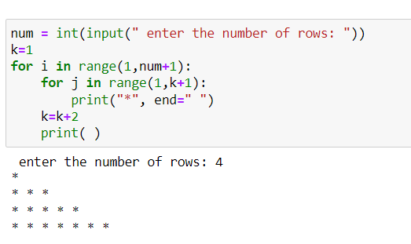

**Q.10. Write a code to create the given structure using while loop.**

**|||||||||**

**|||||||**

**|||||**

**|||**

**Answer:** 